February 02, 2020

Dear Musala Soft software developers,

This document contains information about the following project



and the recreation of the test environment, needed to test the written code.

During the development process the following software was used:

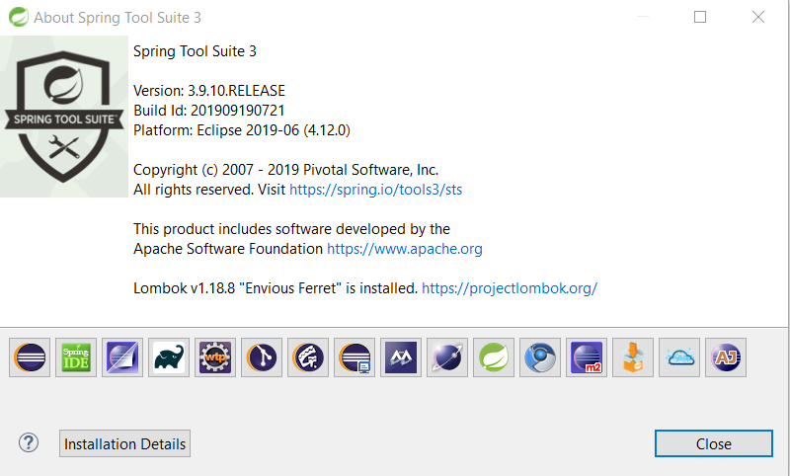

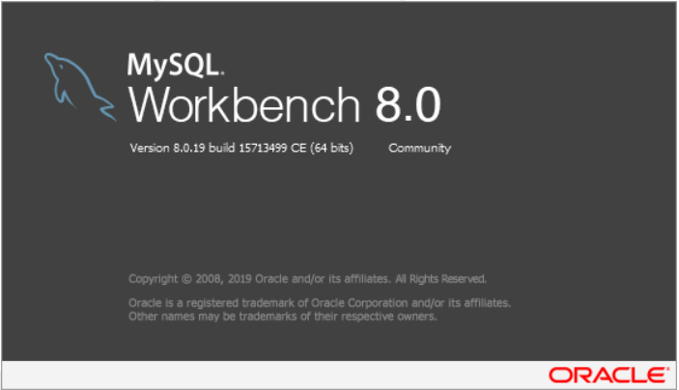

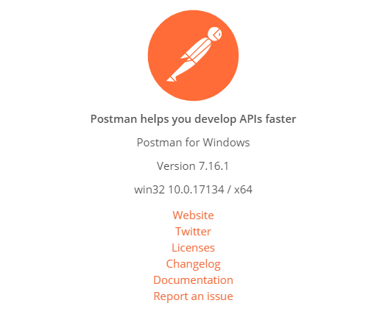

This project could be imported in Eclipse, STS or another Java IDE as a Spring Boot Мaven project, using the project folder

contained in the archive sent to you.

The source code can be found in the following GitHub repository as well:

<https://github.com/YovoManolov/GithubRepJava/tree/master/JAVA%20programs/INTERVIEW_TASKS/MusalaSoft>

The DB scripts, needed to create and fill the test database, could be found in the same archive under the name: scripts.sql.

The scripts inside are in the order, in which they should be executed one by one in MySQL database .

There are no unit tests provided in the project, because, unfortunately, currently I don’t have the knowledge needed to do them properly.

Testing requests are provided and are contained in two “.json” files which could be imported in Postman.

1. gateways.postman_collection.json
2. perifDevices.postman_collection.json

After the project has been started and the database configured, the test requests could be sent .

Sincerely yours,

Yovo Manolov